class Solution {
public:
void reverseString(vector<char>& s) {
int l=0;
int r=s.size()-1;
while(l<r){
swap(s[l],s[r]);
l++;
r--;
}
}
};
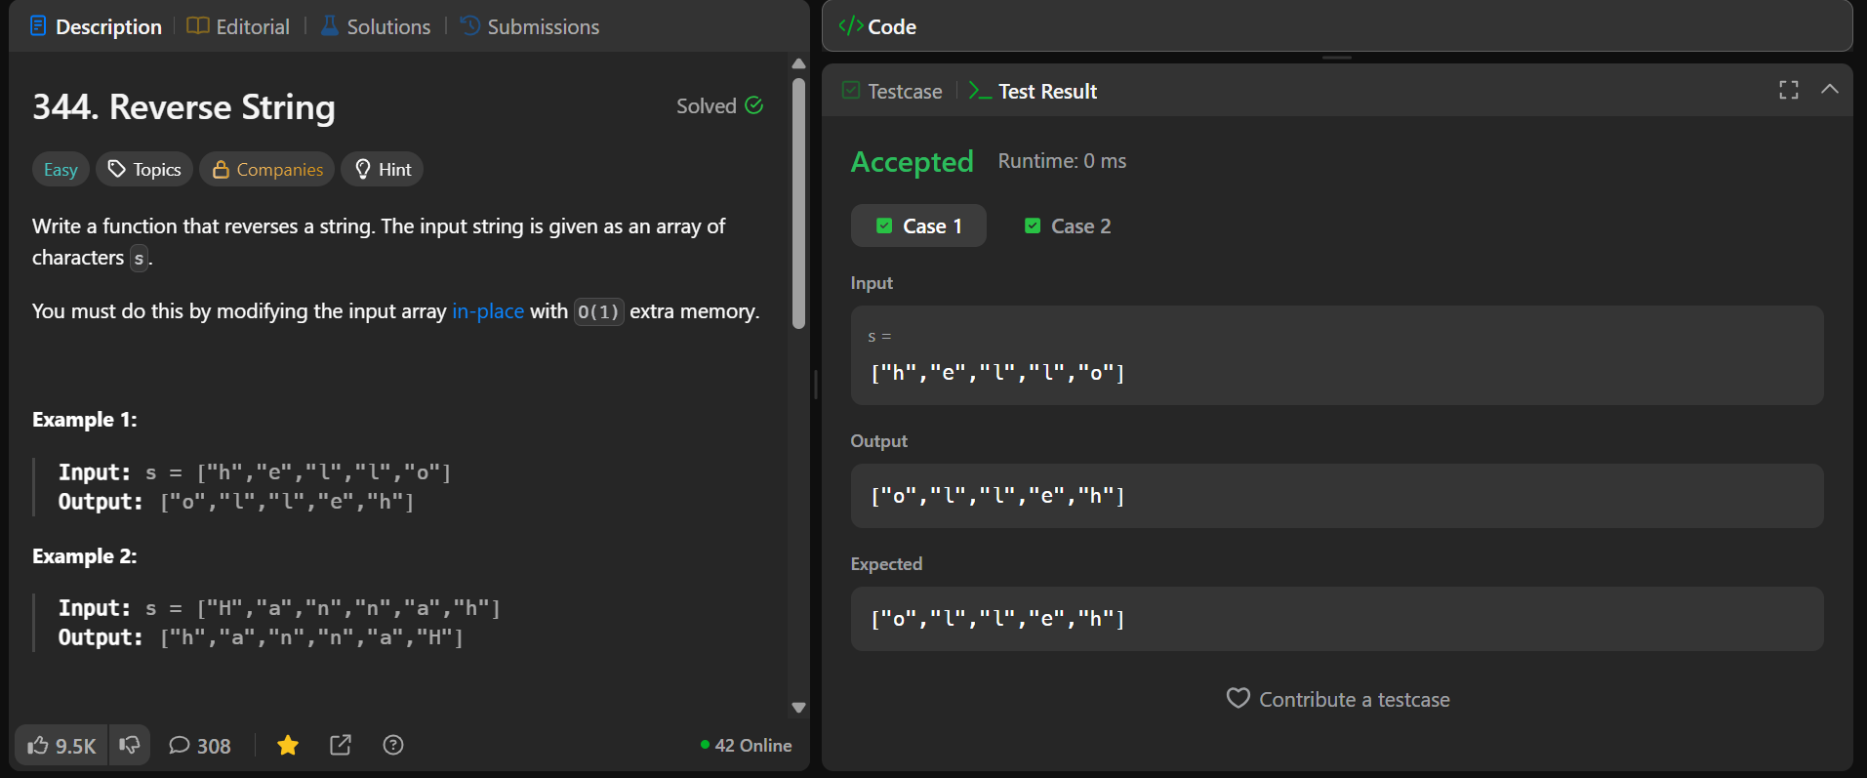
class Solution {
public:
bool isAnagram(string s, string t) {
if (s.length()!=t.length()){
return false;
}
sort(s.begin(), s.end());
sort(t.begin(), t.end());
return (s == t);
}
};
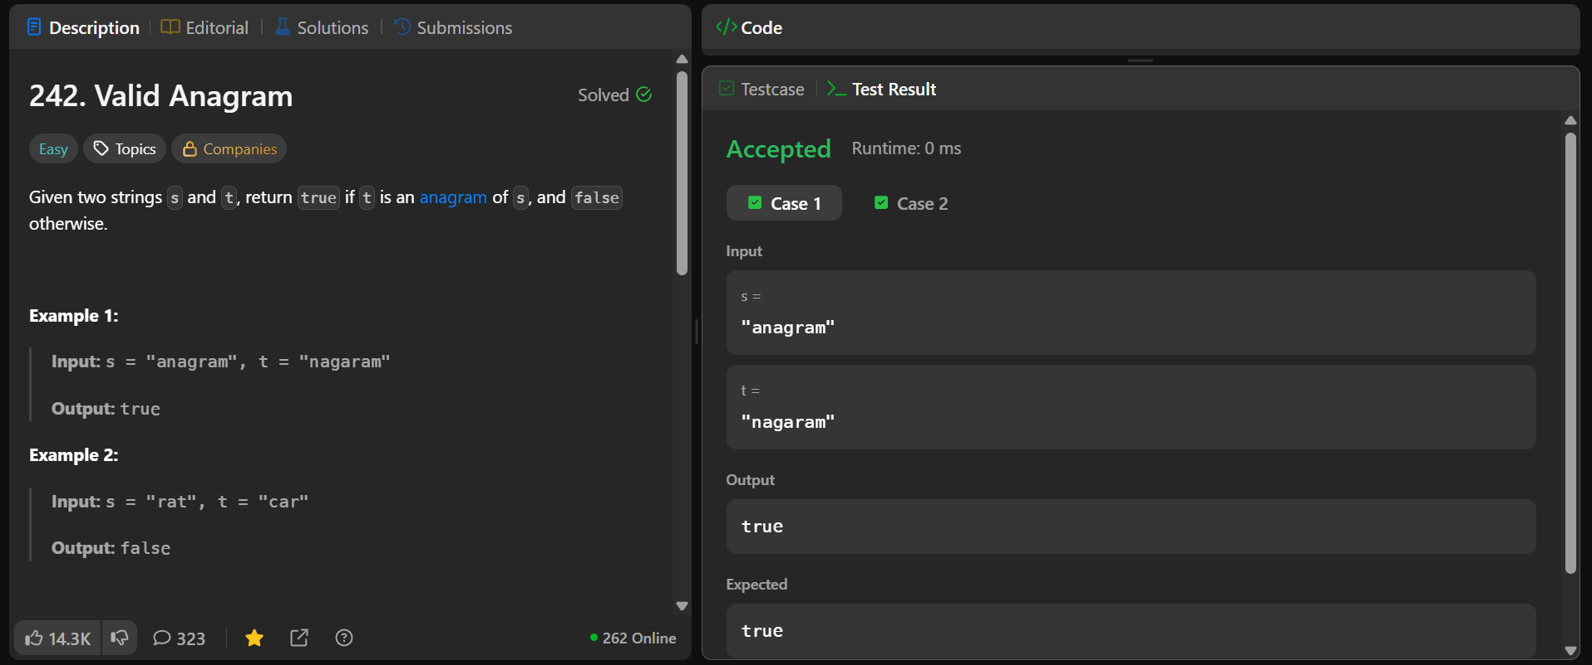
class Solution {
public:
string cleanString(string s) {
string result = "";

for (int i = 0; i < s.length(); i++) {
char c = s[i];

if (isalnum((unsigned char)c)) {
result += tolower((unsigned char)c);
}
}
return result;
}

bool isPalindrome(string s) {
s = cleanString(s);

string rev = string(s.rbegin(), s.rend());
return s == rev;
}
};

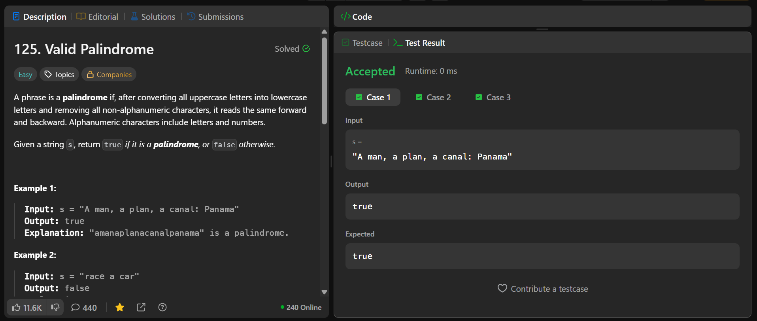
class Solution {
public:
int reverseDigits(int num) {
long long rev_num = 0;
while (num > 0) {
rev_num = rev_num * 10 + num % 10;
num = num / 10;
}
return rev_num;
}
bool isPalindrome(int n) {
int rev_n = reverseDigits(n);
return (rev_n == n);
}

};
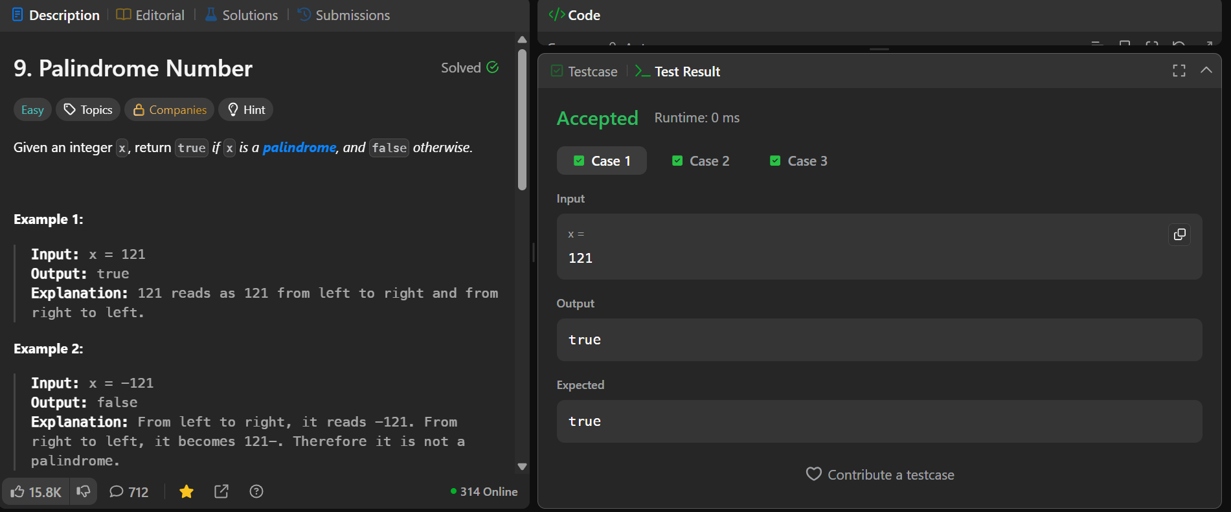
class Solution {
public:
int maxProfit(vector<int>& prices) {
int n=prices.size();
int res=0;
int m = prices[0];
for(int i=1;i<n;i++){
res = max(res, prices[i]- m);
m=min(m,prices[i]);
}
return res;
}

};
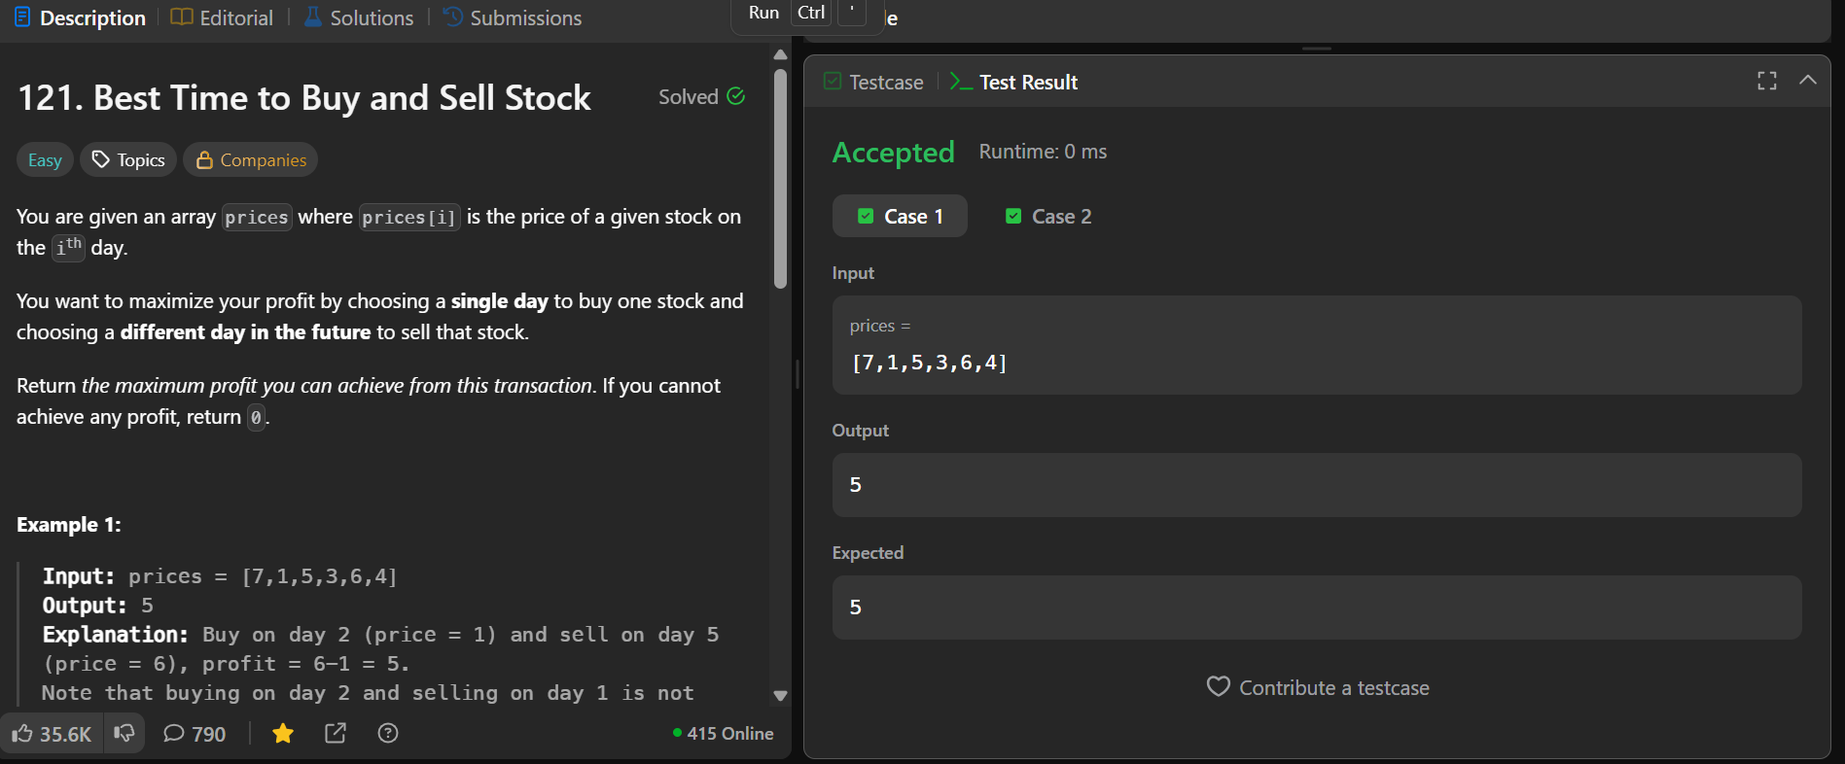
class Solution {
public:
vector<int> twoSum(vector<int>& nums, int target) {
int n = nums.size();
for (int i = 0; i < n; i++) {
for (int j = i + 1; j < n; j++) {
if (nums[i] + nums[j] == target) {
return {i, j};
}
}
}
return {};
}
};

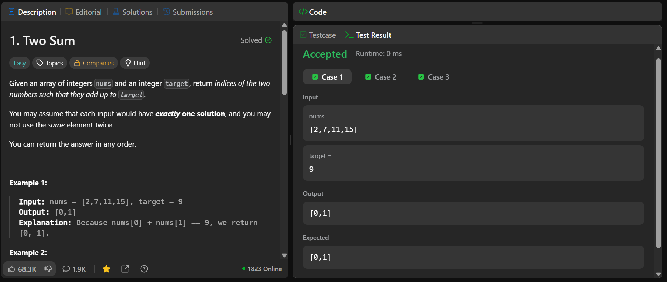
class Solution {
public:
int numSquareSum(int n) {
int sum = 0;
while (n != 0) {
int digit = n % 10;
sum += digit * digit;
n /= 10;
}
return sum;
}

bool isHappy(int n) {
set<int> st;

while (n != 1) {
n = numSquareSum(n);

if (st.find(n) != st.end())
return false;

st.insert(n);
}
return true;
}
};
